OCR-based inventory system for hardware: architecture, APIs, cost.

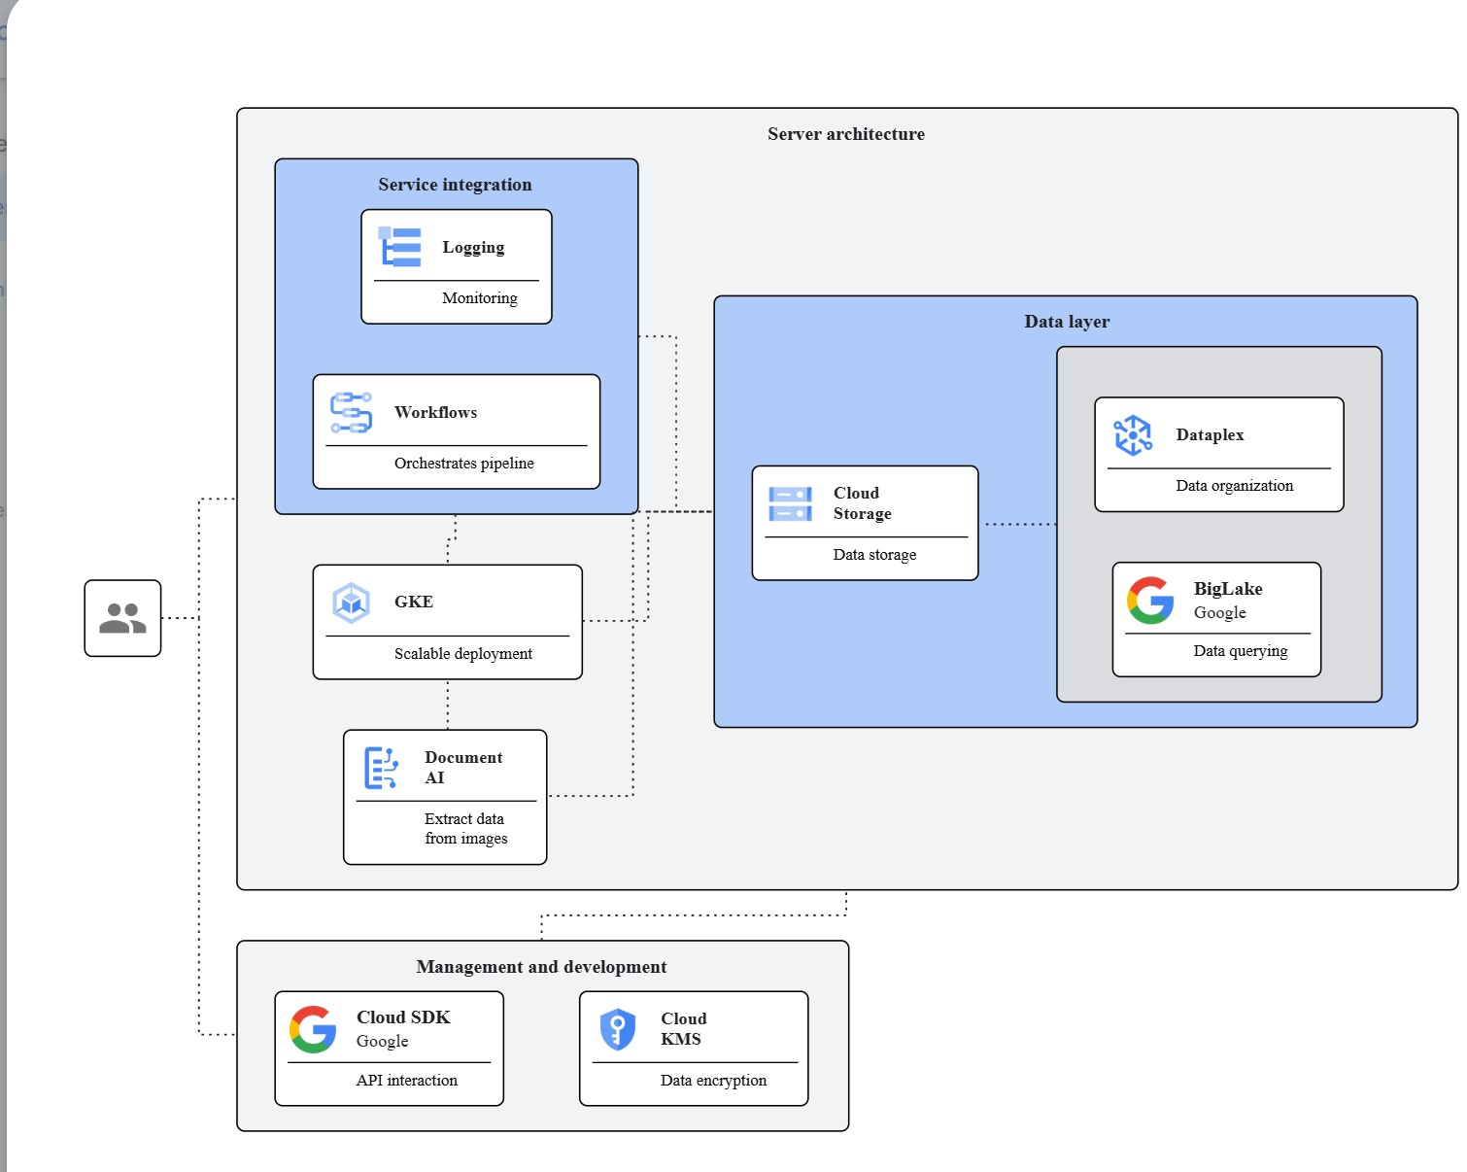

This solution uses a serverless architecture to process images of hardware, extract relevant information using OCR, and store the data in a structured format for later analysis. This approach minimizes infrastructure management and scales efficiently to handle varying volumes of images. The combination of Document AI, Cloud Storage, and Workflows provides a robust and efficient pipeline for processing the inventory data. Cloud Logging helps monitor the process.

1. **Image Upload:** Upload images of the hardware to a [Cloud Storage](https://cloud.google.com/) bucket. Organize images into folders for better management.
2. **Workflow Trigger:** Configure a [Workflows](https://cloud.google.com/) instance to trigger automatically when a new image is added to the Cloud Storage bucket.
3. **Document AI Processing:** The Workflows instance calls the [Document AI](https://cloud.google.com/) API to process each image. Specify the desired data fields (brand, model, serial number, description) in the API request. Document AI will extract this information.
4. **Data Transformation (Optional):** A Workflows step can be added to transform the extracted data into a standardized format suitable for your spreadsheet (e.g., CSV or JSON).
5. **Data Storage:** The processed data is then stored in another Cloud Storage bucket or exported directly to a spreadsheet via a Workflows integration.
6. **Monitoring:** Use [Cloud Logging](https://cloud.google.com/) to monitor the pipeline's performance and identify any errors.
7. **Cost Projection:** Cost estimation requires knowing the number of images, their average size, and the frequency of processing. Use the pricing calculators for Document AI, Cloud Storage, and Workflows to estimate costs based on your expected usage.

**User Requirements that need clarification:**

* What is the approximate number of hardware items to be inventoried?
* What is the average size of the images?
* What level of accuracy is required for the extracted data?
* Do you have existing systems or spreadsheets that need to be integrated with this inventory system?
* What is your preferred method for accessing the final inventory data (e.g., spreadsheet download, API access)?
* What is your desired level of automation (e.g., fully automated, manual triggering)?

This architecture provides a scalable and cost-effective solution. However, **the accuracy of Document AI depends on the quality of the images. Poor image quality may reduce accuracy and require manual intervention**.